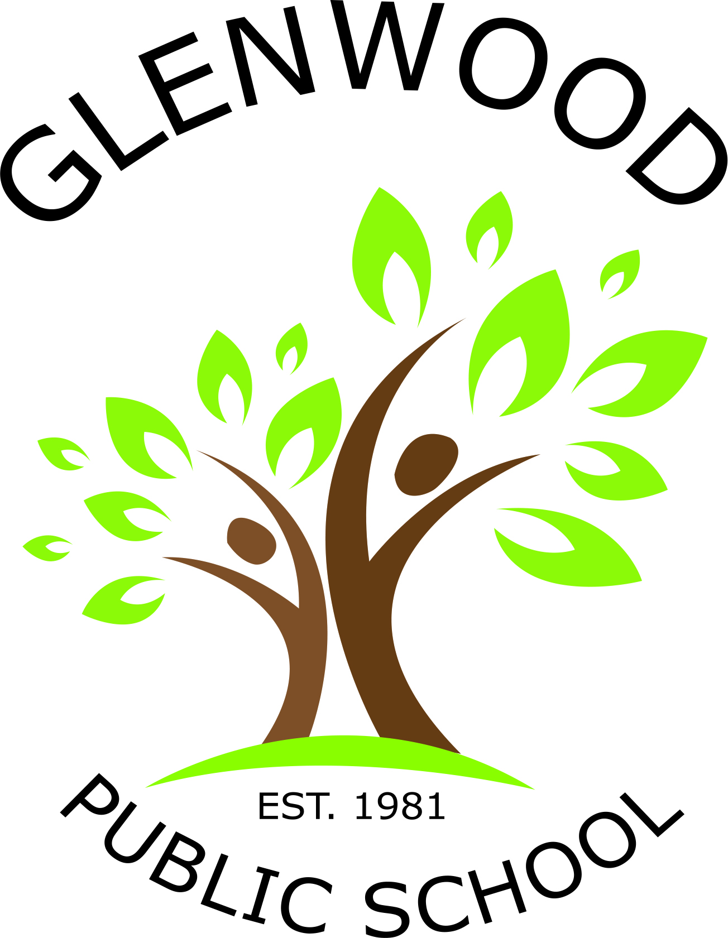
Cnr Belmont Road and Harrow Road
Glenfield NSW 2167
p. 02 9605 3260
e. glenwood-p.admin@det.nsw.edu.au

Stage 1 Public Speaking Competition
Public Speaking is an element of our Speaking and Listening programs within the English syllabus. At school, the teachers work closely with the students to build their skills and confidence in presenting their ideas and opinions. We encourage everyone to be brave and take the opportunity to develop their skills in speaking in front of an audience.

Each year Glenwood holds a public speaking competition where students have the opportunity to speak formally in front of their class. Teachers will use public speaking criteria to nominate two speakers as class representatives for the Glenwood Stage 1 Public Speaking Competition held on Wednesday 28th March.

When | What
Weeks 4 - 7 | Students prepare speech at home. Topics below.
Week 8 | Students present speech in class.
Week 9 | Glenwood Public Speaking Competition

We encourage all students to take part at the class level. Even though your child may not wish to proceed beyond a classroom presentation, it is important that he/she participates by preparing a 2 minute speech. Each speech your child gives provides a wonderful learning opportunity to prepare, practise and reflect upon his/her oral language progress. As students continue through school, these types of presentations are expected across many areas of the curriculum. Our aim is to teach all students skills to develop their manner, matter and method with public speaking so that they can express themselves with a greater level of confidence.

During their speech, students are encouraged to present their ideas and support their point of view with details, research and relevant information. It is important that all speeches are presented in the student’s own words.

Stage 1 Topics 2018 –
If I were teacher for the day
When I grow up I would like to be
Fun with my friends
Surprise!
The best letter of the alphabet

If you require further information, please make contact with your child’s class teacher or one of the coordinators. We look forward to supporting students find their voice, express their opinion and engage an audience.

Miss Weeitch and Miss Tomczyk Mrs Webb
Public Speaking and Debating Coordinators Principal

