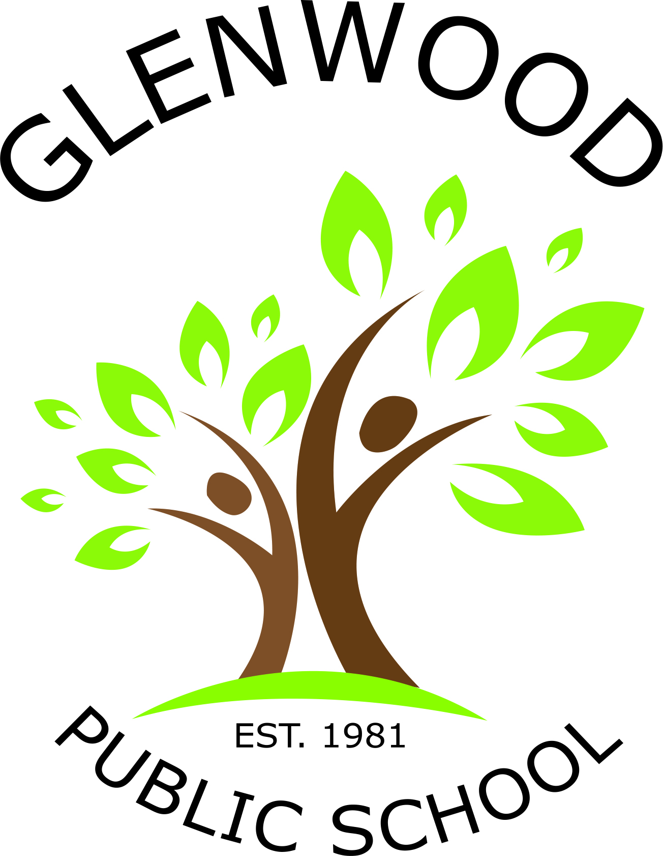

Glenwood Public School
Cnr Belmont Road and Harrow Road
Glenfield NSW 2167
p. 02 9605 3260
e. glenwood-p.admin@det.nsw.edu.au
9/2/2018
ABC Reading Eggs and Reading Eggspress

Dear Parents and Caregivers,

We are excited to provide you ABC Reading Eggs and Reading Eggspress apps and online programs. These programs teach children the core reading and literacy skills they need for success at school. Activities feature highly interactive lessons. The engaging one-on-one learning activities contain colourful animations, fun music and exciting rewards that keep children motivated to learn! These activities can be used for homework and home reading.

You can also find more information at readingeggs.com.au

There is no cost to parents this year. School is funding each student’s subscription.

Class teachers will send your child’s username and password home shortly.

Charmaine Harper Anne Webb
Assistant Principal Principal

