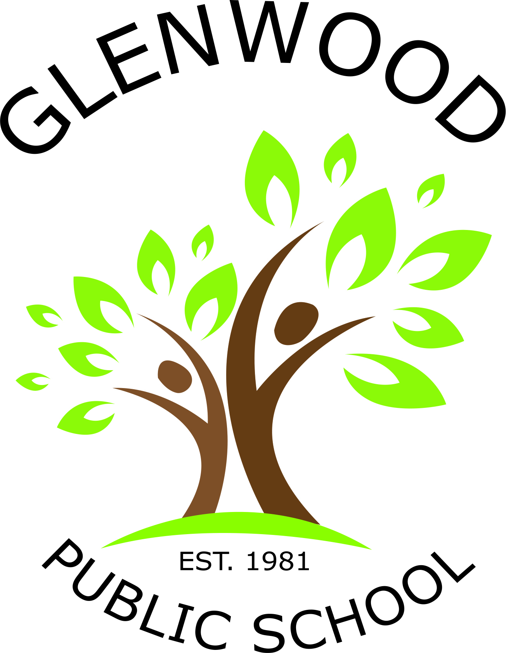
Cnr Belmont Road and Harrow Road
Glenfield NSW 2167
p. 02 9605 3260
e. glenwood-p.admin@det.nsw.edu.au

Musica Viva Incursion
Dear Parents and Caregivers
Glenwood is excited to host its second Musica Viva event, Teranga! Musica Viva has been bringing premium quality live music to Australian schools for over 35 years. They specialise in presenting the best small ensembles Australia has to offer – dynamic, accessible and culturally diverse groups that perform in a wide variety of music styles.

Teranga is led by charismatic Senegalese musician Pape M’Baye (who has shared the stage with music legends (BB King, Miles Davis and Ringo Starr), Teranga’s percussion-based music transports audiences to a world of poetic, rhythmic storytelling, where tales of small village life become metaphors for how we live today. This is sure to inspire and get our students moving.
What: Teranga (West African music)
Who: K - 6
When: Thursday, 9th August, 2018
Time: 9:15am – 10:15am
Where: Glenwood Public School
Cost: $3.00

The show is linked directly to the music curriculum as well as other curriculum areas especially literacy and numeracy. We would be delighted if you could come to the performance.

To confirm your child’s attendance at Teranga please pay, sign and return the permission slip to the office by Tuesday the 7th of August.

For further information, please see Ms Weeitch.

Ms Weeitch Mr McInney
Classroom Teacher Acting Principal
_______________________________________________________________________________________
Please return to the office.
Musica Viva - Teranga
I would like my child to attend Musica Viva.
Child’s name: ________________________________________________________ Class: __________________

I have enclosed payment of $3.00 for the show.

Signed: _____________________________________________________________ Date:___________________

