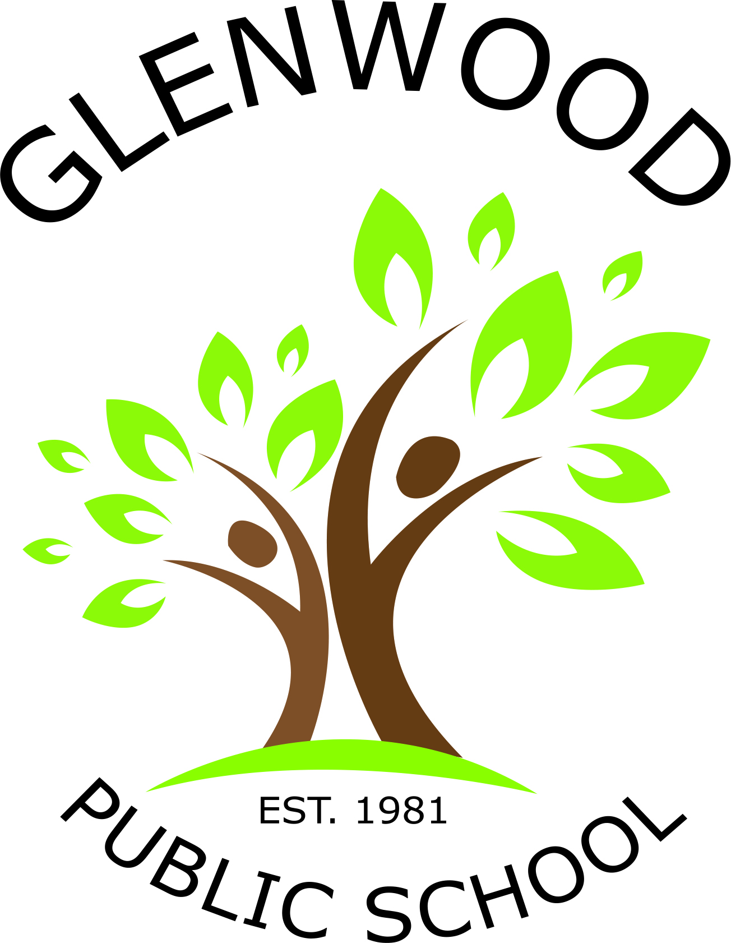
Glenwood Public School
Cnr Belmont Road and Harrow Road
Glenfield NSW 2167
p. 02 9605 3260
e. glenwood-p.admin@det.nsw.edu.au

Kindergarten for 2018

Dear Parents and Caregivers,
Our Kindergarten students for 2018 have made a wonderful start to their school lives. We thank everyone for their positive support and assistance in making a successful transition to school for all our students. This year our class will be known as Kurnell.

Just a reminder to please label your child’s hat, drink bottle and lunch box as it makes it easier to return any lost property to the correct student.

The students are beginning many routines over the next few weeks and one of these is Crunch and Sip. This is a time before lunch where healthy eating is encouraged and students are asked to bring a small piece of fresh fruit or vegetable and a bottle of water. Please assist your child by talking to them about what fruit or vegetable could be eaten during Crunch and Sip time.

Below is a list of resources that the teachers would greatly appreciate for the classroom.

Resources
- Tissues
- Whiteboard markers
- Glue sticks
- Baby wipes
- Pump bottle of hand wash

We look forward to an enjoyable and productive 2018!

Miss Madeline Carreiro &
Miss Jacqueline Parramore Mrs Anne Webb
Kindergarten Teachers Principal

