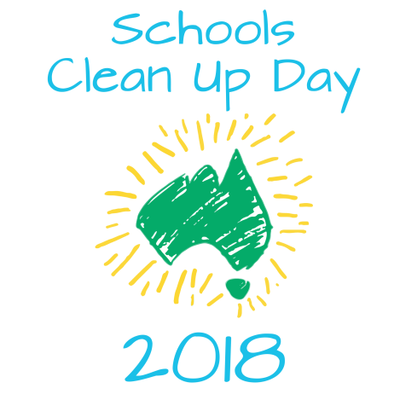
Dear parents and caregivers,
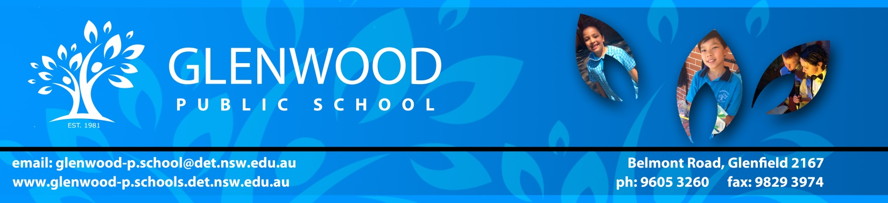
Once again, Glenwood Public School will be participating in the Clean Up Australia Day initiative to promote a cleaner and safer environment! On Friday the 2nd of March (week 5), students will work together to clean up our school playground and school grounds.
Students may like to bring a pair of gardening gloves to wear on the day.
Thank you for your support!

Mrs Anne Webb Miss Jacqueline Parramore
Principal Coordinating Teacher

Dear parents and caregivers,
Once again, Glenwood Public School will be participating in the Clean Up Australia Day initiative to promote a cleaner and safer environment! On Friday the 2nd of March (week 5), students will work together to clean up our school playground and school grounds.
Students may like to bring a pair of gardening gloves to wear on the day.
Thank you for your support!

Mrs Anne Webb Miss Jacqueline Parramore
Principal Coordinating Teacher

