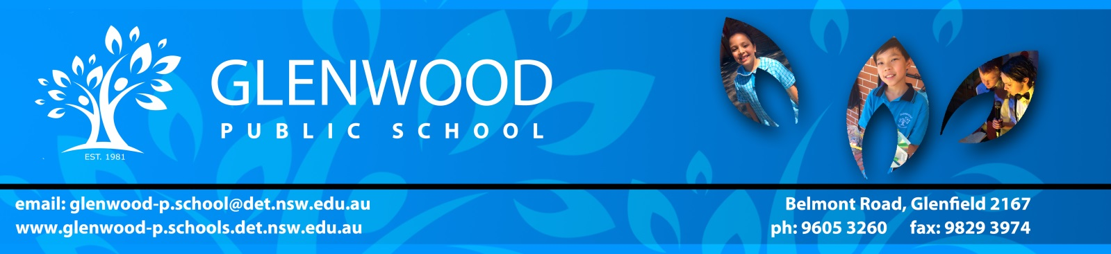

August 13, 2018

Expression of Interest: Cannes Short Film Festival, France
September 6-9, 2018

Hello!
Once again our awesome movie Chocolypse! has been acknowledged on the world stage with a screening in the Cannes Short Film Festival!
The festival will take place in the same city in France that hosts the famed Cannes Film Festival which attracts the movie elite from Hollywood and around the world!
We are putting out an expression of interest to students and parents who may be willing to be a part of the festival in France from September 6 to 9. We are in the earliest stages of determining just how Glenwood can be a part of the festival and no formal arrangements have yet been made.
If there is a possibility of you being interested in travelling to France to attend the festival, please return the slip below.
Thank you!

T. Gough J. McInney
Class Teacher Principal

Expression of Interest: Cannes Short Film Festival, France
September 6-9, 2018

Due Tuesday – 14/08/18 – Expressions of interest are in no way binding and you may change your mind at any time.
I would like to express an interest in my child ______________________________________________________
attending the Cannes Short Film Festival in France from September 6 to 9, 2018.

Name of accompanying parent/s _____________________________________________________________

Signed______________________________________________ Date__________________

