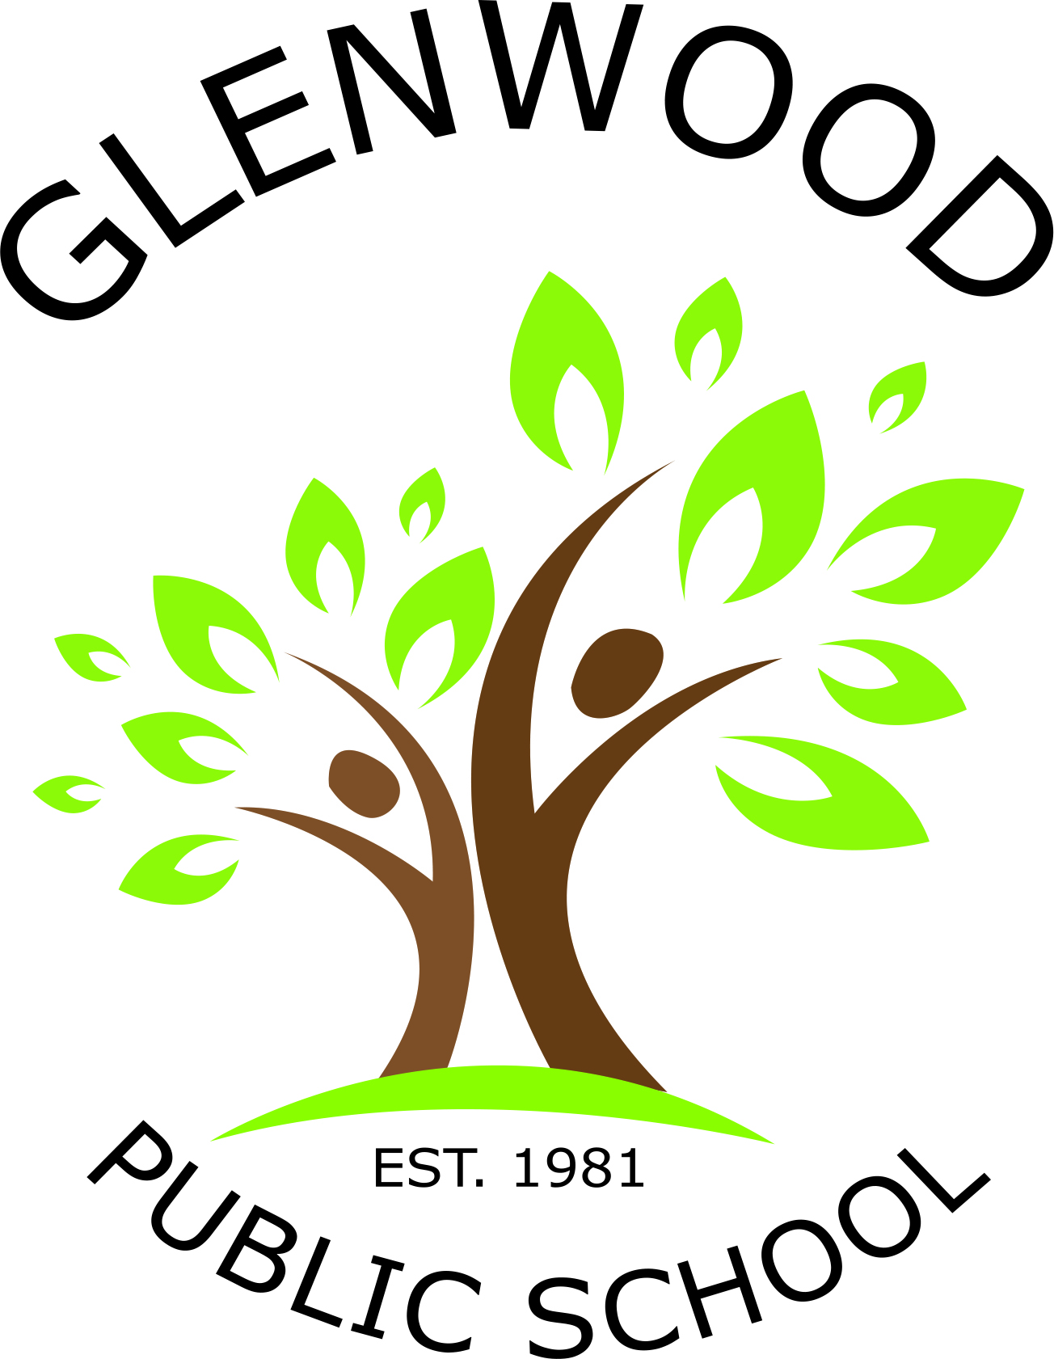
Glenwood Public School
Cnr Belmont Road and Harrow Road
Glenfield NSW 2167
p. 02 9605 3260
e. glenwood-p.admin@det.nsw.edu.au

Years 3-6 Resource List for 2018
Dear Parents and Caregivers,
Welcome back to school for 2018. This year our class will be known as Tamarama. The children are already happily learning and getting to know their teacher and class mates. To get all students ready for learning we ask that you buy the everyday resources from the list below. It is important that your child brings the following resources to school every day to assist with their learning.
Everyday Resources
- Pencil Case
- HB Lead pencils
- Eraser
- 2 red, 2 blue and 2 black pens
- 30cm ruler showing cm and mm
- 1 set of coloured pencils (textas optional)
- Sharpener
- Glue stick
- Scissors
- Library bag
- 2 highlighters
- A book of choice for silent reading
- Headphones or ear buds (to use with iPads and computers)
- USB

Other Resources
- A4 lined homework book (please cover with contact)
- 2 boxes tissues
- Whiteboard markers

Please clearly label all items sent to school with your child.
We look forward to an enjoyable and productive 2018!

Ms Simone Tomczyk Mrs Anne Webb
Classroom Teacher Principal

