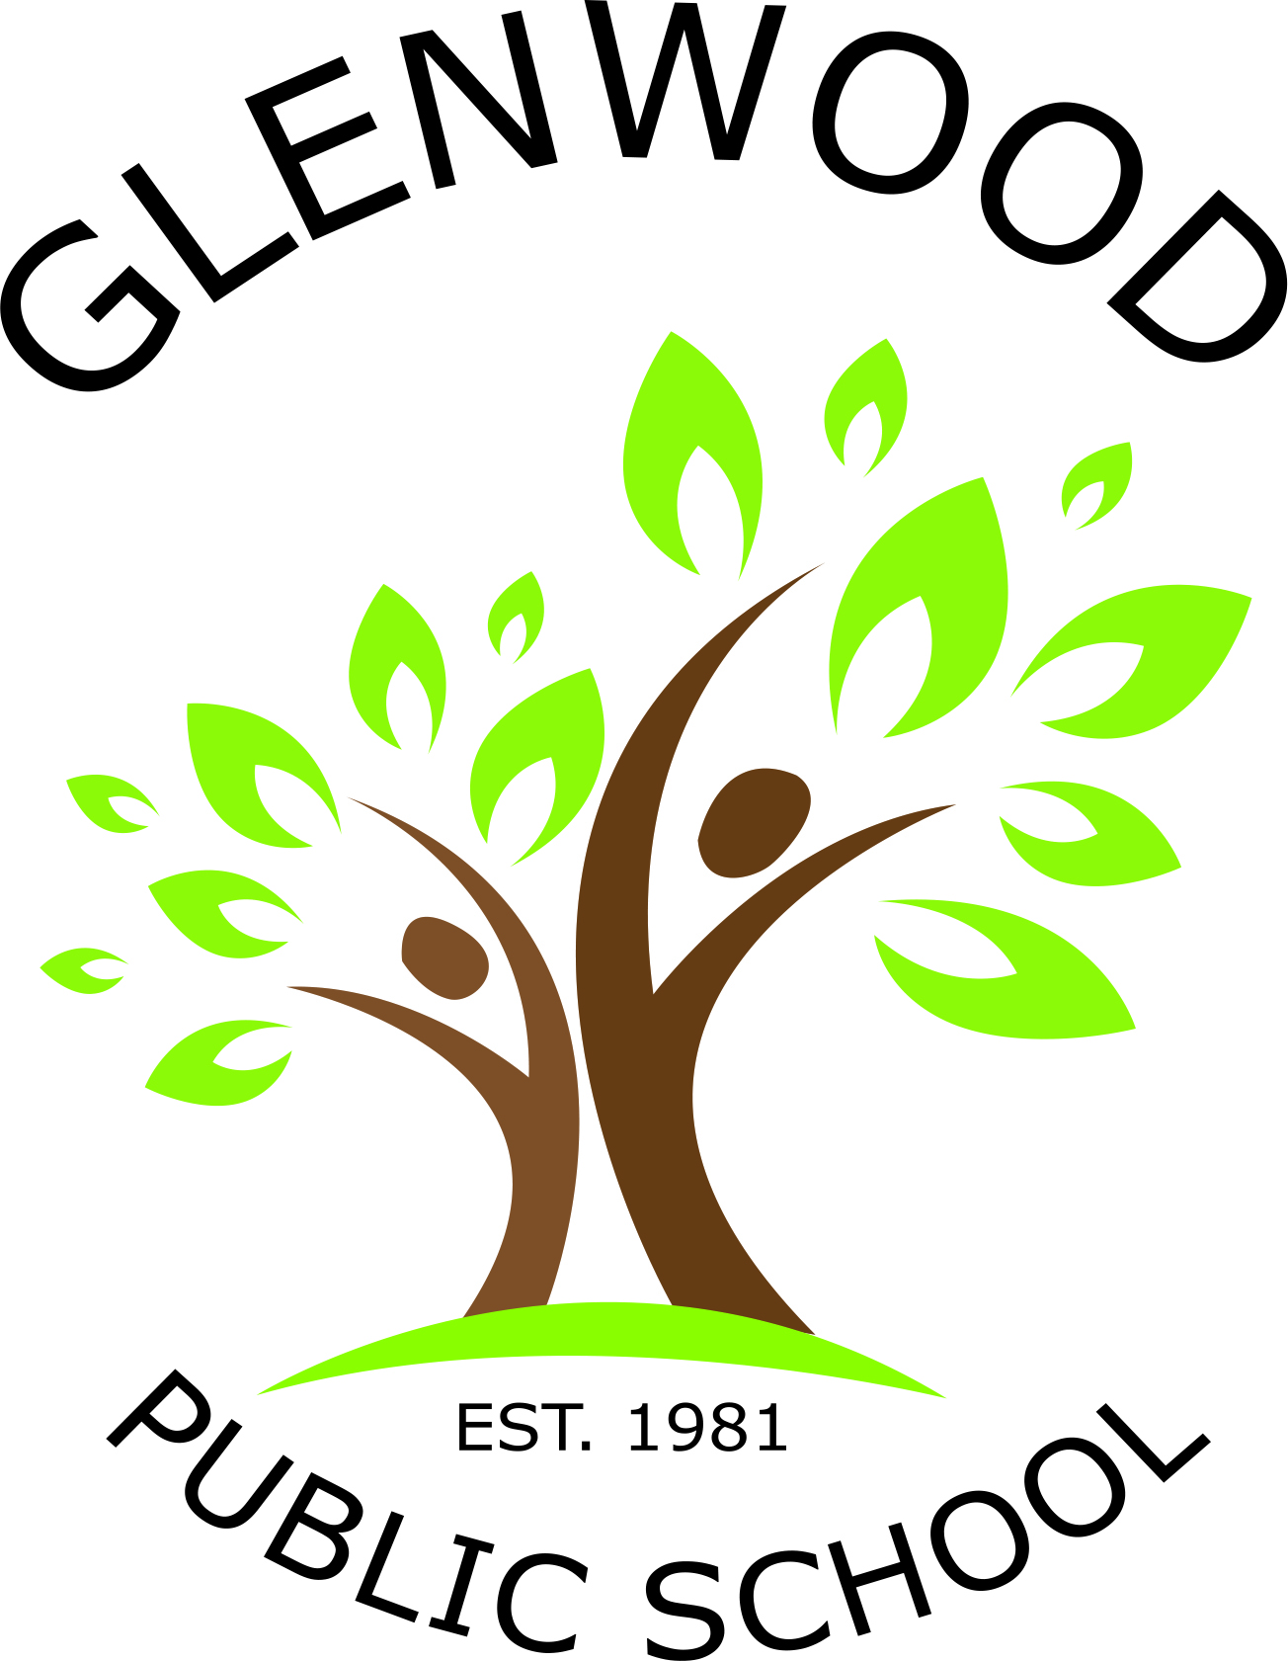
Cnr Belmont Road and Harrow Road
Glenfield NSW 2167
p. 02 9605 3260
e. glenwood-p.admin@det.nsw.edu.au

Public Speaking
Glenwood has a strong tradition in the area of Public Speaking with many of our students performing very well in past years’ competitions.
With the success and enthusiasm exhibited last year, we have decided to keep the implementation of two public speaking competitions again in 2018. These competitions will be organised as follows –

Multicultural Perspectives  Public Speaking Competition  Terms 1 & 2  - All students (Stages 1 – 3) are expected to participate at a class level by writing and delivering a speech based on one of the given topics.  - Two students from each class will be selected to compete at a Stage level in school.  - First and second place winners from Stage 2 and 3 will have the opportunity to represent Glenwood at the area final in Term 2. | Glenfield Group  Public Speaking Competition  Terms 3 & 4  - All students – (1-6) are expected to participate at a class level by writing and delivering a speech based on a topic of their own choosing.  - Two students from each class will be selected to compete at a Stage level in school.  - First place winner from each Stage will have the opportunity to represent Glenwood at the local Glenfield Group Public Speaking Competition.

Public Speaking is an element of our Speaking and Listening programs within the English syllabus. We encourage everyone to be brave and take the opportunity to develop their skills in speaking in front of an audience.
Details regarding the Multicultural Perspectives Public Speaking Competition will accompany this overview. Information and topic ideas for the Glenfield Group Competition will be sent home during Term 3.

Miss Weeitch and Miss Tomczyk Mrs Webb
Public Speaking and Debating Coordinators Principal

