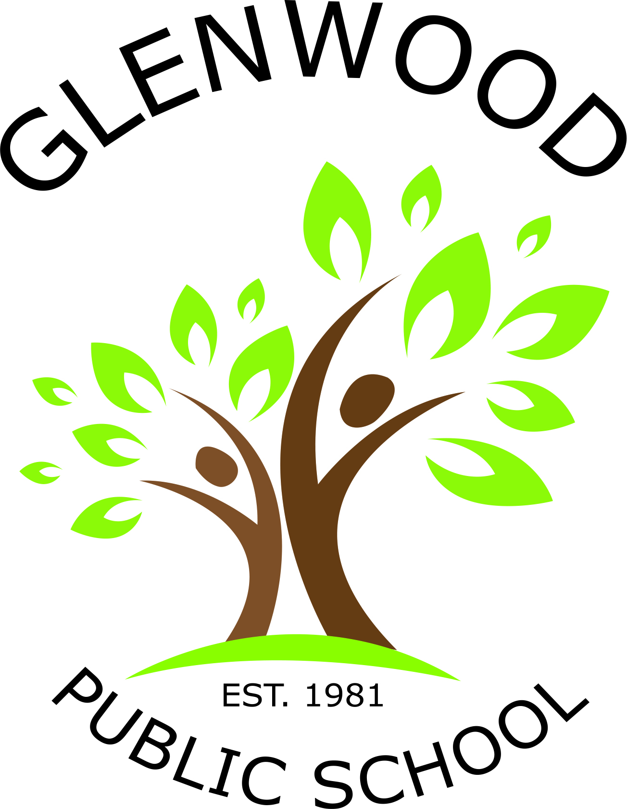
Glenwood Public School
Cnr Belmont Road and Harrow Road
Glenfield NSW 2167
p. 02 9605 3260
e. glenwood-p.admin@det.nsw.edu.au

Stage 1 Resource List for 2018

Dear Parents and Caregivers,

Welcome back to school for 2018. This year our class will be known as Rennies. The children are already happily learning and getting to know their teacher and class mates. Most supplies for your children in K to 2 are supplied by the school.
Below is a list of resources that the teachers would greatly appreciate for the classroom.

Crunch and Sip is a time before lunch where healthy eating is encouraged and students are asked to bring a small piece of fresh fruit or vegetable and a bottle of water. Please assist your child by talking to them about what fruit or vegetable could be eaten during Crunch and Sip time.

Resources
- 1 box tissues
- Whiteboard markers
- Glue sticks
- Baby wipes
- Pump bottle of hand wash
- Library bag
- Headphones (ear buds)
- Paint shirt

Please clearly label all items sent to school with your child.
We look forward to an enjoyable and productive 2018!

Miss Stephanie Renn Mrs Anne Webb
Classroom Teacher Principal

